Mixed-In Size Analysis Program User’s Manual
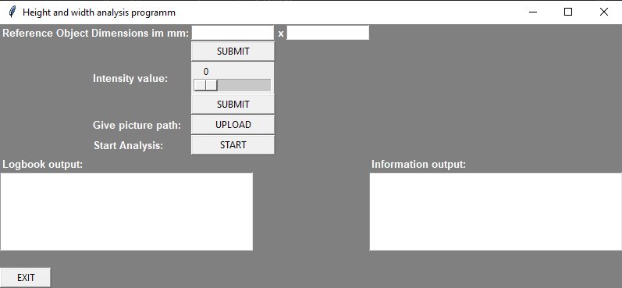
Once you open the .exe file, the interface window will open. If you are using the program for the first time since opening, you will need to enter the width (x) and height (y) dimensions of your reference object in the first two input windows.
The reference object should ideally have a rectangular shape. The longer main axis of the rectangle should always be x and the shorter main axis should always be y. A picture of the ideal reference object is shown below:
y
x

Furthermore, the reference object should be the largest object in the image. This means that all mixed ins should be smaller than it.
For further explanation, the file “referenceSample.jpg” is being used. In this case, the reference object is the blue rectangle on the top left corner.
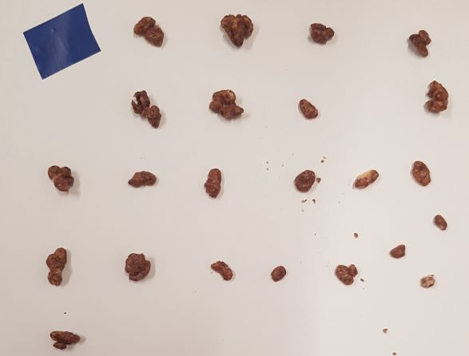
The scaling of the object is 24 mm in width and 18.6 mm in height:
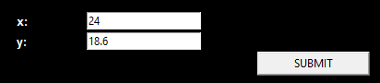
Secondly, choose the intensity value of the canny edge detector. This detector will detect the edges of the objects on the picture. If the value is higher, the contrast between object border and background has to be more intense to be detected as an object outline. If the value is lower, the contrast does not need to be that high anymore. If certain objects are not being detected, turn down the value. If things like shadows or other things, that don’t belong to the mixed ins, are being detected, then increase the value again.
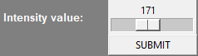
To upload the picture, press the button labelled “UPLOAD”. A file explorer window will be opened. Go to the directory where the picture that has to be analysed is being stored. Then open the file after it has been selected.
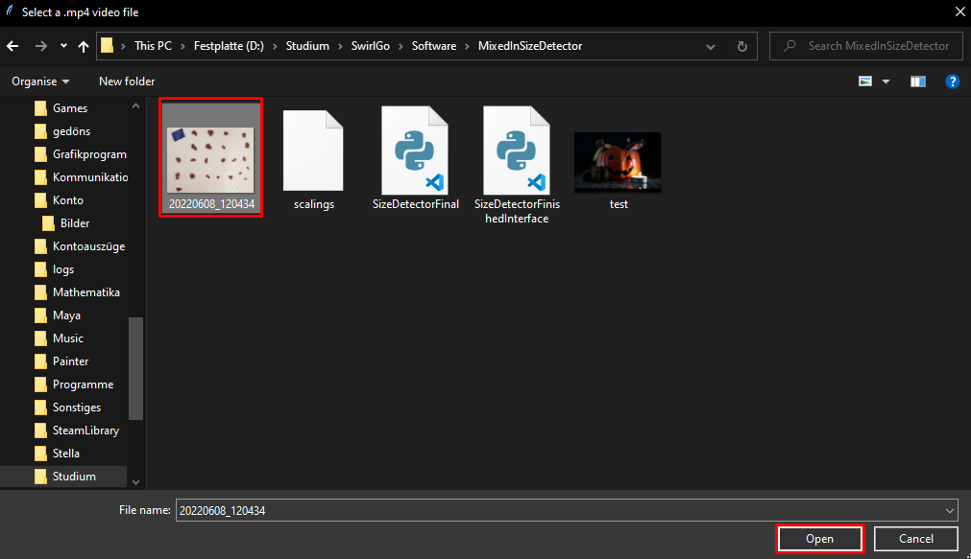
If you are ready to do the analysis, then press the button, labelled “START”. A second window will open, showing the outlines of each object.
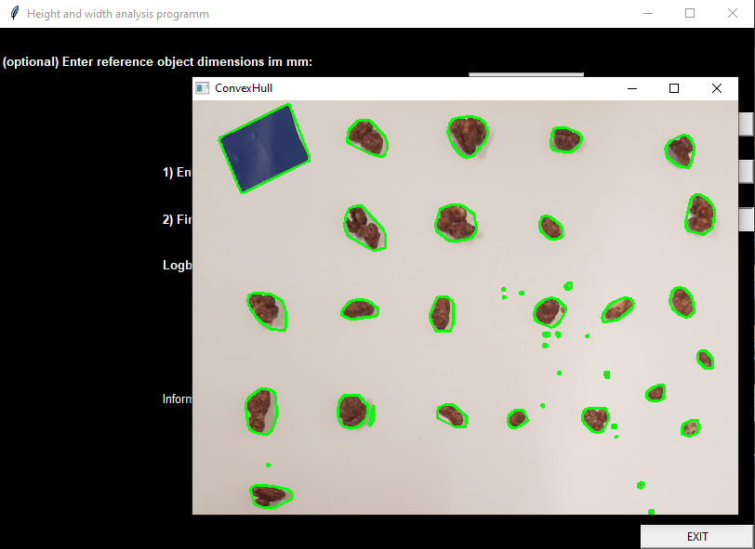
Ideally, the outlines should be as close to the frame of each object as possible. As seen in the picture above, poor lighting and shadows can affect the sample. Result can be that the object’s shadow can be detected as part of the object as well.
If you want to proceed to the analysis, close the recently opened window. A second window will open up, showing which objects have been detected, as valid objects. A red outline will be drawn around each valid object. The reference object is being highlighted in pink.
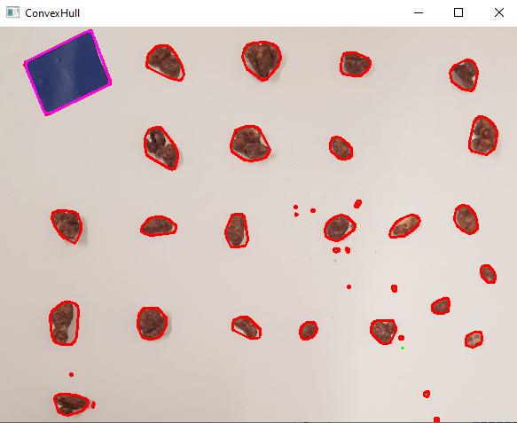
After this window is being closed, the actual analysis starts. As soon as the analysis is complete, a window with two graphs will show up. One of them will show the width of each analysed object, the other one the object width. In both charts, the values are being sorted by value.
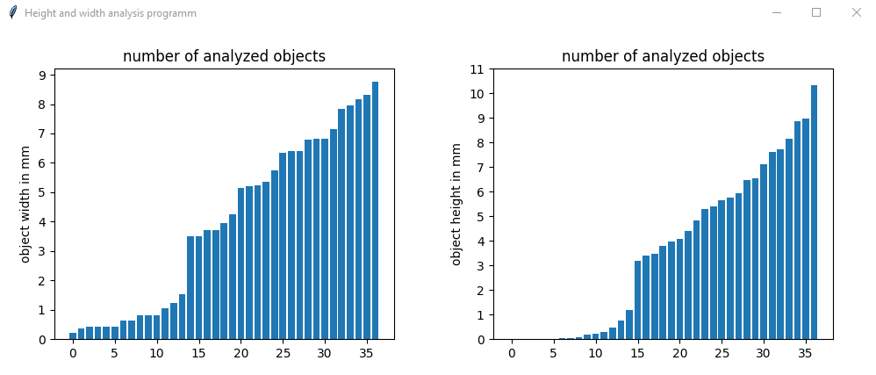
Furthermore, some of the most important values are being printed out in the “Information output” text field in the main window. In this example, the output looks like this:
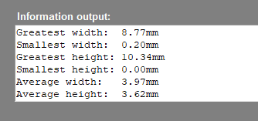
Once you are finished, close the window or press the button labelled “EXIT”.

Building up the stand
- Lighting
Ideally, light the probe far above, directly from the top, so that there is little to no shadow casted from each mixed in to the plane where it is positioned on. The light source should cast an even, strong and smooth light. This will make the probe lighted in the same intensity, which will make the data more accurate. You can just use a standard LED ceiling light, as long as it suffices the criteria. Note that the light intensity also can affect the result of the analysis. If the light is too weak, it will also worsen the result of the analysis.
Example of a ceiling light that suffices the criteria:
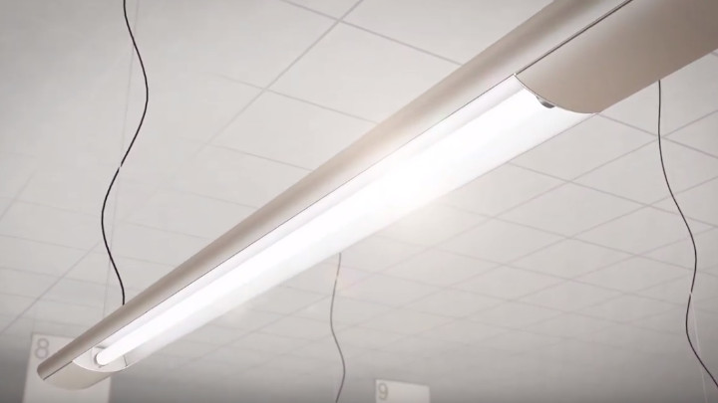
Source: https://www.lighting.philips.com/main/support/purchase/installer/installations

- Background
The background should have a high contrast to the colour of the mixed ins. In most cases, a plain white plane does suffice. If the results don’t seem to work, it is recommended to use a green or blue background such as in the colour of green screens and blue screens in CGI and VFX production.
Also note that the plane has to be only in one colour (monochromatic), without any patterns, folds, creases or other things that can change the colour appearance of the background in the picture.

- Arrangement of mixed ins
Please put enough space between each of the mixed ins, that the program can detect them as individual objects. There are no rules to the arrangement of all the mixed ins, apart from that.
Take an example on the arrangement of the mixed ins as described in the first part of the manual.

- Main picture sample rules

When taking the picture, make sure that the background is monochromatic. This means that the whole background must be of the same texture. The material that you are using as a background should be the only thing on the background that is visible.

